**FROG POPULATION MONITORING PROGRAM**

Participant’s manual:

**Reproductive Call Route Surveys**

Prepared by:

**The St-Lawrence Valley Natural History Society**

For:

**The Ministry of Forests, Wildlife and Parks**

**Updated July 2021**

 

# TABLE OF CONTENTS

TABLE OF CONTENTS ii

PROTOCOL SUMMARY iii

1.0 INTRODUCTION 1

2.0 GETTING READY FOR THE SURVEYS 2

2.1 Route selection 2

2.2 Marking and describing your survey route 3

2.3 Selecting an assistant (if desired) 3

2.4 Identification of the frog calls 4

3.0 CHOOSING THE RIGHT CONDITIONS 5

3.1 The dates 5

3.2 Weather 7

3.1.1 Temperature 7

3.1.2 The wind 8

3.1.3 Precipitation 8

3.1.4 Previous weather conditions 8

4.0 THE SURVEY 9

4.1 Necessary material 9

4.2 Filling in the Route Survey Form (with a pencil) 10

4.3 Listening stations 10

4.4 Ambiant noise 11

4.5 Amphibian sightings 11

4.6 Returning the survey data 12

5.0 TROUBLESHOOTING AND ACKNOWLEDGEMENTS 13

6.0 AVAILABLE RESOURCES 14

6.1 Field guides 14

6.2 Frog call recordings 14

6.3 Mobile application (frog calls) 14

6.3.1 Android devices 14

6.3.2 Apple devices (iPhone, iPad, …) 14

6.4 Meteorological conditions and forecasts 15

6.5 Thesis based on the statistical analysis of the Program’s data 15

APPENDIX 1. Québec’s climate zones based on annual average temperatures 16

APPENDIX 2. The Beaufort scale of wind force. 17

APPENDIX 3. Number of days separating the snow melt date between Québec’s different climate zones 18

# PROTOCOL SUMMARY

* Choose one or two quiet and long (8 km) routes that cross various representative habitats in your area. For each route, ten listening stations are distributed every 0.8 km;
* Visit the route during the day to recognize and mark, if necessary, the 10 listening stations to survey. Fill in the listening route’s descriptive sheet;
* Once created, the route will be permanent and will only be modified for exceptional reasons (i.e. security) following the approval of the program coordinator;
* Familiarize yourself with the identifying calls of the anuran present in your area before carrying out surveys (CD, website, mobile application);
* Survey each route twice. Each survey should begin no earlier than half an hour after sunset, when winds are calm and evenings are relatively hot and humid for the period. Each route has ten stations where you will listen for 3 minutes to identify and count frogs. As you go you will record your observations on a Route Survey Sheet. Each survey outing should take between an hour and an hour and a half to complete;
* It is very important to complete all the information requested on the Route Survey Sheet. Note the wind and weather conditions at the beginning and end of the survey period. Record the time, the listening quality, the presence of noise and the call index for each species heard at each station;
* The first surveys target the wood frog and should be undertaken early in the spring, shortly after the snow and ice melt. The wood frog breeding season is short (10 days), it is therefore better to go early and risk having to go out again later than to go too late and miss the species;
* The second surveys target the American toad. This survey is normally conducted 2 to 4 weeks (average 20 days) after the peak of the wood frog’s breeding season. Space both surveys out at least 7 days apart. Temperatures must be 15 ° C or higher for the second survey. The American toad season lasts longer and takes longer to reach peak activity levels;
* The spring peeper’s breeding season is long. The species will be surveyed during both surveys;
* Return a copy of each completed Route Survey Sheet before September 1st to the St. Lawrence Valley Natural History Society, either by e-mail (scanned copy), by mail or by fax.

# INTRODUCTION

In Canada as in several other parts of the world, amphibian populations are declining due to habitat loss and other factors such as air pollution, emerging diseases, ultra-violet radiation, etc. In response to this crisis, the International Union for the Conservation of Nature (IUCN) has been initiating long-term amphibian population follow-up projects in several countries since the early 90’s. In Québec, the *Ministère des Resources Naturelles et de la Faune* (MRNF) began a pilot project in 1993 to determine the feasibility of starting a long-term frog population monitoring project. The St-Lawrence Valley Natural History Society then received the mandate to develop and operate this pilot project, which later became the official Frog Population Monitoring Program of Québec (1997). The Program is still running to this day and stimulates the collaboration of several people and organizations working in frog conservation from across the province.

In the early years of the Program, all frog species were being monitored. Nevertheless, after 10 years of population monitoring, it was discovered that only 3 species generated enough data to allow for the detection of statistically significant population trends (Garant, 2004). Those species are the American toad (*Anaxyrus americanus*), the spring peeper (*Pseudacris crucifer*) and the wood frog (*Lithobates sylvaticus*). Consequently, the protocol was modified in 2006 in order to target these species specifically as they became the main indicators used to monitor the long-term trends of frog populations in Québec.

This manual will provide you with all the necessary information to take part in an anuran (frogs and toads) population follow-up project that consists of surveying reproductive calls of species along a given route. In essence it is quite simple. Ideally, the same routes are surveyed by the same participants every year and the information taken includes the species heard as well as an indication of the number of “callers” given by an index value. This enables us to determine if the number of frogs and toads heard increases, decreases, or remains constant from year to year. To ensure validity of data collected, all participants must conduct their surveys in the same manner. This manual will describe the steps to be followed.

# 2.0 GETTING READY FOR THE SURVEYS

## 2.1 Route selection

**Routes are selected by the project coordinator with the help of the participants.** Routes already in use for the Breeding Bird Survey (BBS) can be used for this survey as well. BBS routes are ideal; not only do they meet our guidelines, but it will also be possible to compare our new frog data with the information that they have gathered over the years.

Here are some factors to consider while selecting your route:

* The route should be **8 km long**.
* Select a route that is in the **straightest possible line** in order to cover the largest area.
* It is a good idea to start your route at a landmark such as a bridge or an intersection.
* Select a **quiet road** with only two lanes that is not a main traffic artery and is far from any highway. It is important to avoid distracting noises such as passing cars, planes, industries, machines, dogs or heat pumps.
* **Avoid selecting a seasonal road** as it may not be accessible during the frog monitoring period in the spring.
* Choose a route **close to home**, especially if you are going to survey two routes. The ideal time to begin listening for frogs is half an hour after sunset and continues until midnight. Each route takes approximately 1 - 1 1/2 hours to survey. If you decide to survey two routes, choose them in such a way that you can travel easily from one to the other, while not allowing any overlap.
* Choose a route that will give you **a good return of frog calls for the effort given**. The route should represent a variety of habitats of the region, but should also include some good amphibian habitats.
* Once you have chosen and surveyed a route, it cannot be changed of modified in any way unless there is a major reason, which has also been discussed and approved with the project coordinator. **A survey route is permanent.** If you have any problems with your road, please list them at the bottom of your data sheet once you have completed your survey.
* Plan a few extra kilometers at the end of your route so that you can add new stations if necessary. If hearing at one station becomes permanently impossible, the station can be eliminated and another added at the end of your route, after approval by the coordinator.

Once you have chosen a survey route, we hope that you will consider it as you own, and that you will survey it every year for as many years as possible. If after a few years you cannot survey your route any longer, we hope that you will be able to find someone to take your place. If you cannot, contact the Program coordinator so that he can help you find a replacement. The pertinence of the data collected in this survey increases as years go by and as the surveyors remain constant.

In order to avoid conflict with local residents of your survey routes as the surveys take place at night, we propose two means of communication: either a press release in the local papers or a letter to the residents signed by the Program coordinator. The press release will inform the local residents about the Frog Population Monitoring Program as well as the presence of participants in their area. If you want to proceed with the press release, it is important that you provide us with the name and address of the newspaper you want to publish in **before April 1rst**. Also, a letter directed to the local residents is available on demand and you can photocopy it and distribute it along your survey routes.

## 2.2 Marking and describing your survey route

Once you have validated the selection of your route with the coordinator, you must visit the route during the day so you can identify the 10 survey stations and select landmarks that will aid in the location of these stations at night. You must be able to recognize each survey station in the dark when you will be doing your surveys. A description of the permanent landmarks for each station should be written on the **Descriptive route survey form.** These landmarks are very important as they will serve as a reference for you in the upcoming years and will allow for future participants to locate the stations.

In accordance with other road surveys, such as the Amphibian Survey in Ontario and the Breeding Bird Survey, stations have been spaced at a distance of **0.8 km**. It is very important to respect this distance while surveying, even if it is tempting to get closer to frog breeding habitat. Do not use your car's odometer to calculate the distances in between the stations since these odometers are often inaccurate. You must therefore be able to recognize each survey station by other means, such as streams, houses, forests, topography, etc.

## 2.3 Selecting an assistant (if desired)

Everyone can survey a frog call route, but some may be hesitant to travel alone at night along poorly or unlit secluded roads. For this reason or another, you may wish to find a partner to assist you in your surveys. This person can help you locate listening stations along your route, mark down information such as weather conditions on the data sheet, and keep track of the time while you are surveying the frogs. In order to ensure the regularity of the data, only one participant (always the same person) should identify and count the frog calls. The person counting the calls is the observer while the person timing is the assistant. Calls heard by the assistant and not by the observer should be noted in the comment section of the data sheet. Make every attempt to ensure that the same person counts the calls for all surveys. Nevertheless, your assistant can take your place if you are unavailable or can no longer participate in the Program. Surveying with a partner allows a greater number of people to participate and allows new participants to profit from the experience of partners who have surveyed in previous years. The partner system also assures that a route will be surveyed over a longer period of time.

## 2.4 Identification of the frog calls

If you wish, we can provide you with a CD of frog calls from species native to Québec to practice your identification skills, or you can listen to the online recordings (also available for download) on the website of the Atlas of Amphibians and Reptiles of Québec ([www.atlasamphibiensreptiles.qc.ca](http://www.atlasamphibiensreptiles.qc.ca)) or on the website of Frog Watch (<https://www.naturewatch.ca/>). There is also a list of websites providing frog call recordings at the end of this document as well as two mobile device applications (section 6.0). **Before conducting your first survey, make sure that you are familiar with the calls of the wood frog, the American toad and the spring peeper as well as other species that might also be present in your area**. Prior to your first survey, you can also practice assigning abundance indexes to frog calls.

It is a good idea to bring along a recorder or a smart phone when you are surveying as well as your frog call recordings in case you have problems identifying some of the calls in the field. Some mobile device applications can listen to the anuran calls in the field, as an internet connection is not required (see suggestions in section 6.0). You may also want to record any calls you cannot identify, for example calls of rarer species or of species outside of their distribution range. These recordings will need to be confirmed by experts.

**NOTE:** **The spring peeper (*Pseudacris crucifer*) occasionally emits a short trill that can be mistaken for the call of a Gray Treefrog (*Dryophytes* (*Hyla*) *versicolor*) or a Western Chorus Frog (*Pseudacris triseriata*).This trill can be heard on the AARQ website.**

# 3.0 CHOOSING THE RIGHT CONDITIONS

Surveys should begin **half an hour after sunset.** Search engines like Google (www.google.ca) can quickly provide you with the sunset time for the current day in your area.

In order to be sure that the frogs and toads are calling while you are surveying, you should keep track of local weather conditions and choose an **optimal time**. Results can be disappointing if it is too cold, dry or windy. Weather conditions seem to be less predictable earlier during the breeding season. During the night, temperatures can quickly dip below those optimal for frogs and toads to call. For these reasons, it is important to respect the proposed start time, 30 minutes after sunset, so that you do not start too early or too late. If conditions deteriorate while you are surveying, stop the survey and return another evening. This section describes the parameters which you should consider in order to select the best moment.

## 3.1 The dates

Since all frog and toad species do not call at the same time, participants are asked to survey their route twice during the year. During the first survey, species that reproduce early in the season should be heard: the wood frog, the spring peeper and, in certain cases, the American toad. **The wood frog has the shortest reproductive period, therefore, conduct your first survey while it is calling, and you should also hear other early-reproducing species as well.** The second survey should take place during the reproductive period of the American toad. The spring peeper can be heard again at this time.

Here are some dates to **guide** you in the selection of the survey dates. These dates may vary from year to year, however, depending on whether spring arrives early or late and depending on the depth of snow on the ground in your climate region. Climate regions are defined on average annual temperatures (see Appendix 1). **You should therefore always rely on the weather** to determine when you should do your survey within these suggested dates (see next section).

Table 1. Survey dates proposed for Québec’s different climate zones.

|  |  |  |  |
| --- | --- | --- | --- |
| **CLIMATE ZONE**  (Annual mean temperature) | | **SURVEY 1\***  (wood frogs) | **SURVEY 2**  (American toads) |
| A | 5.0 to 6.5˚C | April 1st to May 1st | May 1st to May 31st |
| B | 3.5 to 5.0˚C | April 11th to May 11th | May 11th to June 10th |
| C | 2.0 to 3.5˚C | April 18th to May 18th | May 18th to June 17th |
| D | 0.5 to 2.0˚C | April 26th to May 26th | May 26th to June 25th |
| E | -1.0 to 0.5˚C | May 3rd to June 2nd | June 2nd to July 2nd |

* The survey should be undertaken at the beginning of this period if spring is early (melted snow and warm temperatures). Conversely one should choose the end of the proposed period if spring is late.

**The list of listening routes, their associated climate zones and a detailed map of all listening routes are available in the Excel spreadsheet attached to the protocol document (Appendix4_Frog Monitoring Program.xlsx). The program coordinator can provide you with your route number if you have forgotten it. Some routes lie at the limit of two climate zones, the suggested survey dates can be adapted to reflect this reality.**

Do not wait until the last minute to do your surveys; if you must redo one, you may not have enough time before the target species’ calling period ends.

**Important note: allow for at least 7 days between the first and second survey.**

Although the suggested dates for the first and the second surveys follow each other closely, it can take from 2 to 4 weeks (average of 20 days) between the abundance peak for the wood frog and that of the American toad itself even if both species can be heard during the same survey (Figure 1). This delay varies from season to season depending on weather conditions, so it is important to adjust as needed. For example, this delay could be shorter if there is a late spring (late survey dates for the wood frog) with temperatures warming up quickly thereafter ("normal" or early survey dates for the American toad).

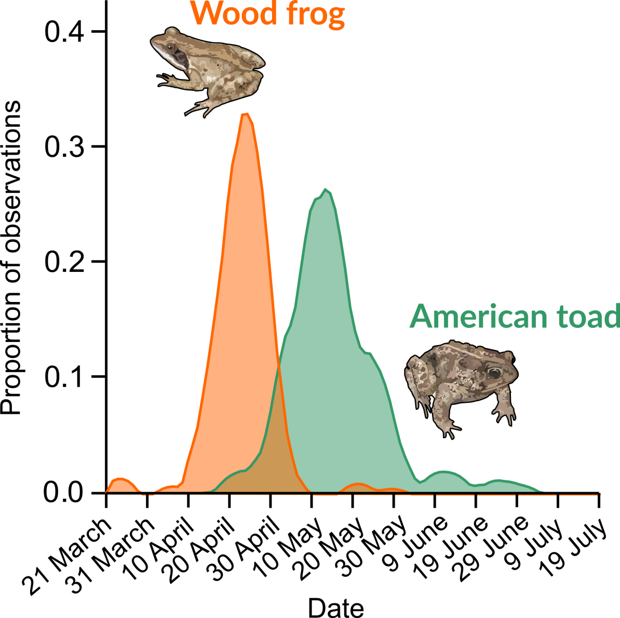

**Figure 1.** Chorus observation frequency (call index of 3) for wood frog and American toad by date in climate zone A (5.0 to 6.5 ° C) from 1993 to 2018. Note the breeding season is shorter for the wood frog compared to that of the American toad. Although both species can be heard at the same time, also note the gap between chorus peaks of both species

## 3.2 Weather

### 3.1.1 Temperature

**The first survey:** The selection of dates for the first survey is the most difficult to ensure the right day to begin. It is very important to remember that this survey must be conducted very early in the season to detect the presence of early species such as the wood frog. Calls from this species will be heard as soon as the ice melts, often when the ground is still partially covered with snow. The wood frog’s reproductive season is short and spans only 10 days or so for any given reproduction area. You should therefore, ideally, choose a warm spring night within the suggested dates (section 3.1) to conduct your first survey. Remember that the survey start date must be adjusted according to weather conditions related to either early or late spring arrivals. A cloudy sky or foggy conditions are ideal as the first light warm drizzles of spring are very effective to stimulate amphibian reproductive activity. The temperature does not seem to be as important for these species to breed, as they will frequently form choruses at temperatures as low as 5oC.

**For the second survey:** The predicted minimum temperature during the day should be above 15°C as the toads are particularly active when the night temperatures are between 10°C and 20°C, reaching their peak at 15°C (Garant, 2004). Again, a cloudy sky and humid weather will yield the best results. If the frogs and toads are very active even though the temperature is a few degrees below those recommended, you may still undertake your survey. Those conditions should be noted on your survey form.

### 3.1.2 The wind

Survey only when the wind is not above an index factor of 3 on the Beaufort Wind Scale (or 20km/h, see Appendix 2). If it is strong enough to lift dust or a piece of paper and make tree branches sway, it is too windy to survey. In addition to traditional weather prediction sites (i.e. Environment Canada, The Weather Network, etc.), some specialized sites provide access to live anemometers and provide very good short-term wind forecasts (Section 6.0).

### 3.1.3 Precipitation

Nights that are humid, with a light rain are ideal to survey your routes, as are the foggy nights. Heavy rain, on the other hand, can interfere with your ability to hear frogs and toads.

### 3.1.4 Previous weather conditions

Previous dry spells or periods of cold can suppress calling. Choose a rainy night or a night following rain or warm weather.

# 4.0 THE SURVEY

Note: Surveys must be performed **half an hour after the sunset.**

## 4.1 Necessary material

You will need a few items to perform your route survey. Table 2 provides a few suggestions of items you can bring with you.

Table 2. List of the necessary material to bring while performing the route surveys

|  |  |
| --- | --- |
| **Item** | **Function** |
| * 1 thermometer | To mark down the air temperature at the beginning and at the end of your survey. |
| * 1 watch and timer | Mark down the time at each station and to measure the 3 minutes of listening required for each station. |
| * 1 copy of the Route Survey Form | To mark down the collected data. |
| * Map of your survey route | To remember the location of each station. |
| * 1 copy of the protocol | In case you have forgotten any detail. |
| * Warm clothes | Temperatures drop quickly during the night, especially in the Spring! |
| * Rain coat | In case of rain. |
| * Plastic boots (optional) | In case of rain or to visit some habitats. |
| * Camera (optional) | To take picture of your discoveries (i.e.: salamanders crossing the road). |
| * Flashlight (optional). | To discover the surroundings! |
| * Cell phone or pad (optional) | To listen or record some frog calls. |

## 4.2 Filling in the Route Survey Form (with a pencil)

Before starting your survey, use a pencil to fill out the top section of the **Route survey form**. Drive to the beginning of your route and assess the weather conditions. Look at the cloud cover and write down if the sky is clear, partly cloudy or overcast. Wind can be evaluated using the Beaufort scale (Appendix 2). Note if the precipitation status is null, light, (including drizzle) or heavy. **Bring along your thermometer** so you can take the air temperature at the beginning and at the end of your survey.

## 4.3 Listening stations

If necessary, drive to the first listening station of your route (point 1) and write down your odometer reading and the time (using the 24 hour clock: i.e. 1:00 pm = 13:00). Stop your engine and get out of your car, moving away from it so that the ticking will not interfere with your hearing. Wait a few minutes to allow for the disturbance caused by your arrival to subside. Estimate the number of individuals of each species that are calling by using the following abundance call indexes:

0 - none heard

1 - individuals can be counted

2 - some individuals can be counted, others overlapping (absence of chorus)

3 - full chorus, calls continuous and overlapping, individuals not distinguishable (some individuals that are close by can be counted but individuals in the group cannot).

To help you figure out which abundance index to attribute, we have created a short training video, available online: <https://www.youtube.com/watch?v=7fy51E3RG6I>. Unfortunately, this video is currently only available in French.

**WARNING:** Do not adjust the abundance index to make up for some species’ characteristics. For example, the American toad has a very long trill and overlapping of two individuals occurs frequently. Consequently, only three or four toads are needed at a station to obtain an abundance index of 2. Surveyors **must** use the same abundance index for all species, even if an index 2 represents a different number of individuals for species such as the American toad.

On your route survey form, write down the **maximum abundance index value** for each species heard at each station. Include everything that you can hear coming from every direction and from as far away as possible. To increase your hearing capacity, it is recommended to cup your hands as illustrated in Figure 2. If, for any reason, surveying becomes impossible at a station, contact us to see if the station should be eliminated and replaced.

At each station, listen for **3 minutes**. Write down the abundance index, making sure you don't forget to indicate the **listening quality** (good, medium, poor). This is based upon the number of times noise interferes with your ability to hear well. Drive to the next station and repeat.

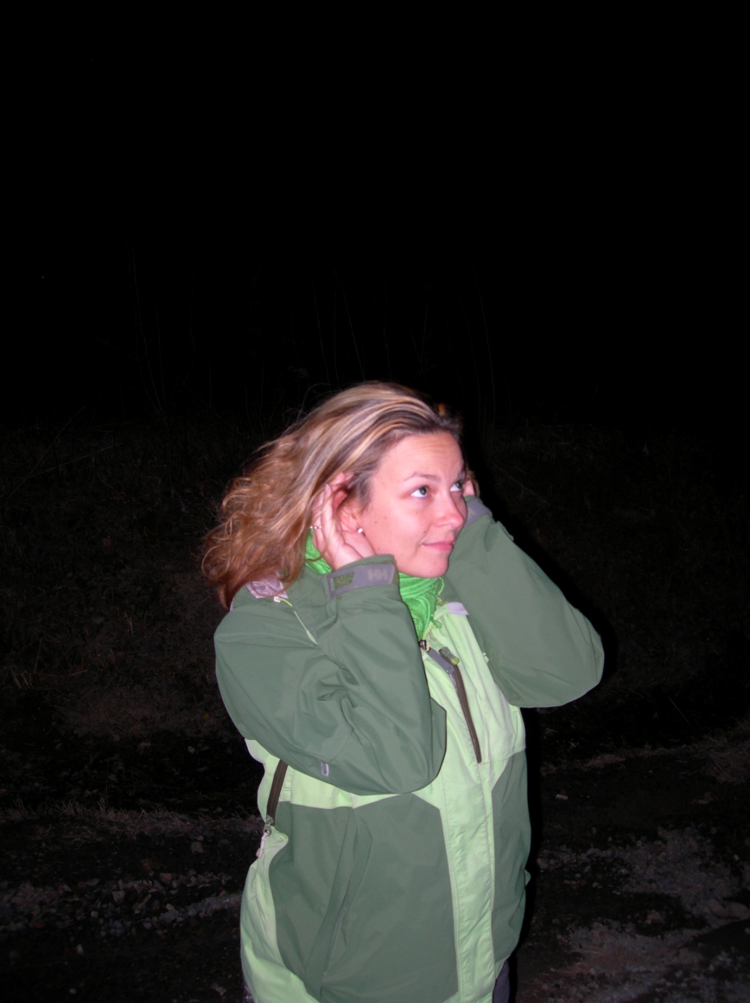

Figure 2. Disposition of hands to increase hearing capacity.

## 4.4 Ambiant noise

Despite the careful selection of routes, there will be times when noise from a barking dog or a passing car will cover the calls you are trying to hear. During these times, stop counting until the noise has diminished, then continue until you have reached 3 minutes. For example, if a pick-up truck disturbs you one minute into your count, wait about 30 seconds to give it time to pass, before counting for the last 2 minutes. **If noise interferes with your count, place an X in the section under Noise.**

## 4.5 Amphibian sightings

If you see any live or dead frogs or salamanders on your route, stop briefly to identify and record your sighting. Several identification field guides are available in stores (see section 6.0). Write down the species observed between the stations on the comment sheet by placing station numbers in parenthesis. Since it is preferable to complete surveys early in the evening (before it gets too cold), the time spent observing animals should be limited in order to concentrate on the call survey.

## 4.6 Returning the survey data

Once you have completed your surveys, return a scanned copy of each filled survey form, along with the copy of your route and a note confirming your participation for the following year to:

**Eric Guerra-Grenier**

St-Lawrence Valley Natural History Society

21 125 chemin Sainte-Marie

Sainte-Anne-de-Bellevue, Québec

H9X 3Y7

Fax: 514-457-0769

Email: [eric.guerra-grenier@ecomuseum.ca](mailto:eric.guerra-grenier@ecomuseum.ca)

We would like to receive all the survey forms before **September 1st** in order to begin the data analysis.

# 5.0 TROUBLESHOOTING AND ACKNOWLEDGEMENTS

If you encounter any difficulties with your survey, or if you have any questions about the protocol, feel free to contact:

**Eric Guerra-Grenier**

St-Lawrence Valley Natural History Society

21 125 chemin Sainte-Marie

Sainte-Anne-de-Bellevue, Québec

H9X 3Y7

Fax: 514-457-9449 ext. 106

Email: [eric.guerra-grenier@ecomuseum.ca](mailto:eric.guerra-grenier@ecomuseum.ca)

**Acknowledgements:**

This protocol manual is based on survey methods developed by the Ontario Task Force on Declining Amphibian Populations. We would like to thank the members of this group, M.E. Gartshore, M.J. Oldham, R. Van der Ham, and F.W. Schueler, who have helped us enormously throughout this project.

**Good luck and thank you for your participation! Without your devotion, this project would not be possible!**

# 6.0 AVAILABLE RESOURCES

## 6.1 Field guides

Desroches, Jean-François et David Rodrigue. 2018. Amphibiens et reptiles du Québec et des Maritimes. Revised and augmented edition. Les Éditions Michel Quintin, Waterloo, Québec, 375 pages.

Cook, F.R. 1984. Introduction to Canadian Amphibians and Reptiles. National Museum of Natural Sciences, National Museums of Canada, Ottawa. 211p.

Conant, Roger and J.T. Collins. 1991. A Field Guide to Reptiles and Amphibians of Eastern/Central North America. (3rd edition) Houghton Mifflin Co., Boston. 450 p.

## 6.2 Frog call recordings

**FrogWatch.** (online). <https://www.naturewatch.ca/frogwatch/quebec/>

**Atlas of Amphibians and Reptiles of Québec (AARQ)** (online, website in French only).

<https://www.atlasamphibiensreptiles.qc.ca/wp/>

Elliot, Lang et Ted Mack. (Pierre Verville as narrator). 1991. **Les sons de nos forêts** (CD). Le Centre de conservation de la faune ailée de Montréal. Cassette.

## 6.3 Mobile application (frog calls)

Allows one to listen, off-line, to various calls from different Canadian species of anuran, including species from Québec. Also contains photos and biological information on each species.

### 6.3.1 Android devices

Name: **Frog Calls** (FREE, English only)

By: Nielsen Family Creations

<https://play.google.com/store/apps/details?id=com.johneyboy.frogcalls&hl=en_US>

### 6.3.2 Apple devices (iPhone, iPad, …)

Name: **Frog Sounds - Toad, Greenhouse Frog** (FREE, English only)

By: Javed Khan Pathan

<https://itunes.apple.com/us/app/frog-sounds-toad-greenhouse-frog/id1187617471?mt=8>

Table 3. List of frog species present in Québec available in the mobile applications

|  |  |  |
| --- | --- | --- |
| **Common name**  (Species present in Québec) | **Mobile App** | |
| **Frog Call** (Android) | **Frog sounds**  (Apple) |
| American bullfrog | X | X |
| Green frog | X | X |
| Leopard frog | X | X |
| Mink frog | X | X |
| Wood frog | X | X |
| Boreal chorus frog | X | X |
| Western chorus frog | X | X |
| Spring peeper | X | X |
| Gray treefrog | X | X |
| American toad | X | X |
| Pickerel frog | X | Missing |

## 6.4 Online abundance index training video (French only)

SLVNHS. 2021. Suivi de populations d'anoures du Québec – Identification des cotes de chants d'anoures. https://www.youtube.com/watch?v=7fy51E3RG6I, published on April 23rd avril 2021.

## 6.5 Meteorological conditions and forecasts

**The Weather Network** (online) <https://www.theweathernetwork.com/ca>.

**Environnement Canada** (online) <https://meteo.gc.ca/forecast/canada/index_f.html?id=QC>

**Windguru** (wind) <https://www.windguru.cz/map/spot/?lat=49.226318089387874&lon=-69.34538461793134&zoom=6.5>

**Windfinder** (wind) <https://fr.windfinder.com/#6/49.8805/-71.3672/2019-04-13T00:00Z>

## 6.6 Thesis based on the statistical analysis of the Program’s data

Garant, Marie-Pierre. 2004. Analyse des données du programme de suivi des routes d’écoute d’anoures. Mémoire de Maîtrise. Département de mathématiques et de statistique, Faculté des sciences et de génie, Université Laval. 99 p. (available upon request as PDF).

Calvé, Thierry. 2017. Dynamiques des populations d’amphibiens du Québec entre 1993 et 2013. Mémoire de maîtrise en biologie, Université du Québec en Abitibi-Témiscamingue. 103 p. (available upon request as PDF).

# APPENDIX 1. Québec’s climate zones based on annual average temperatures

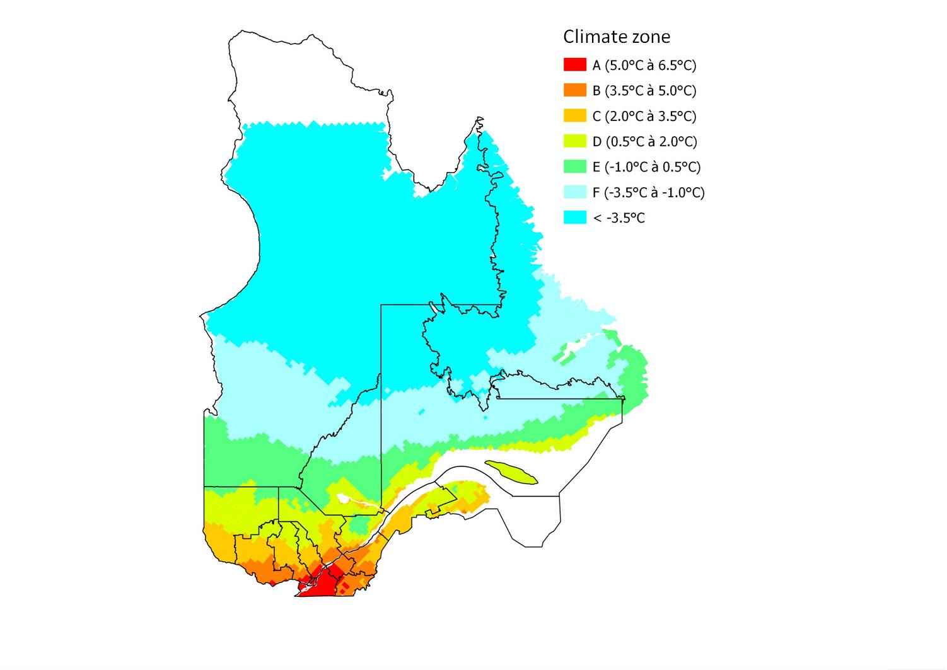**Note:** a detailed map showing the call routes superimposed on climate zones is available in the Excel spreadsheet attached to the protocol (Appendix4_Frog Monitoring Program.xlsx)

# APPENDIX 2. The Beaufort scale of wind force.

|  |  |  |  |  |  |
| --- | --- | --- | --- | --- | --- |
|  | **Beaufort**  **number** | **Description** | **Wind speed (knots)** | **Wind speed (km/h)** | **Effects** |
| **Good conditions** | 0 | Calm | <1 | <1 | Calm. Smoke rises vertically. |
| 1 | Light air | 1 - 3 | 1 - 5 | Wind motion visible in smoke. |
| 2 | Light breeze | 4 - 6 | 6 - 11 | Wind felt on exposed skin. Leaves rustle. |
| 3 | Gentle breeze | 7 - 10 | 12 - 19 | Leaves and smaller twigs in constant motion. |
| **Wind too strong** | 4 | Moderate breeze | 11 - 15 | 20 - 28 | Dust and loose paper raised. Small branches begin to move. |
| 5 | Fresh breeze | 16 - 20 | 29 - 38 | Branches of a moderate size move. Small trees begin to sway. |
| 6 | Strong breeze | 21 - 26 | 39 - 49 | Large branches in motion. Whistling heard in overhead wires. Umbrella use becomes difficult. Empty plastic garbage cans tip over. |
| 7 | High wind, Moderate Gale, Near Gale | 27 - 33 | 50 - 61 | Whole trees in motion. Effort needed to walk against the wind. Swaying of skyscrapers may be felt, especially by people on upper floors. |
| 8 | Fresh Gale | 34 - 40 | 62 - 74 | Twigs broken from trees. Cars veer on road. |
| 9 | Strong Gale | 41 - 47 | 75 - 88 | Larger branches break off trees, and some small trees blow over. Construction/temporary signs and barricades blow over. Damage to circus tents and canopies. |
| 10 | Whole Gale/Storm | 48 - 55 | 89 - 102 | Trees are broken off or uprooted, saplings bent and deformed, poorly attached asphalt shingles and shingles in poor condition peel off roofs. |
| 11 | Violent storm | 56 - 63 | 103 - 117 | Widespread vegetation damage. More damage to most roofing surfaces, asphalt tiles that have curled up and/or fractured due to age may break away completely. |
| 12 | Hurricane-force | ≥ 64 | ≥118 | Considerable and widespread damage to vegetation, a few windows broken, structural damage to mobile homes and poorly constructed sheds and barns. Debris may be hurled about. |

# APPENDIX 3. Number of days separating the snow melt date between Québec’s different climate zones

|  |  |  |  |  |  |
| --- | --- | --- | --- | --- | --- |
| Climate zone | A | B | C | D | E |
| A |  | 10 | 17 | 25 | 31 |
| B |  |  | 7 | 15 | 22 |
| C |  |  |  | 8 | 15 |
| D |  |  |  |  | 7 |
| E |  |  |  |  |  |

The beginning of the wood frog's breeding season is strongly correlated to snowmelt. The following table provides the average number of days between snowmelt from one climate zone to another and can be used to guide the planning of surveys. For example, the wood frog's breeding season in Zone B would begin approximately 10 days after Zone A, and the Zone E season would start one month later (31 days) than Zone A and so on.